Logic Building Programs

WEEK-1
- Write a Python program to check whether agiven number is even or odd.
Algorithm:
  - start
  - give input two numbers
  - if num%2==0,then give num is even
  - else give num is odd
  - stop
num = int(input("enter a num: ")) if num%2 == 0:
print("num is even")
else print("num is odd")
In [16]:
num is odd
- Write a Python program to check whether a number ispositive, negative, or zero.

Algorithm
- Start
- Input a num
- If num>0
- Display "Positive number"
- Else if num<0
- Display "Negative number"
- Else
- Display "Zero" 9)Stop
num = int(input("enter a num :")) if num>0: print("num is positive")
elif num<0:
In [18]:
print("num is negative")
else:
print("num is equal to zero")
num is negative
3. Write a Python program to find the largest among three numbers.

Algorithm
- Start
- Input three numbers: A, B, C
- If A>B and A>C
- Display "A is the largest" 5. Else if B>A and B>C
6. Display "B is the largest" 7. Else
- Display "C is the largest"
- Stop
num1 = int(input("enter a num: ")) num2 = int(input("enter a num: ")) num1 = int(input("enter a num: ")) if num1>num2 and num1>num3: print("num1 is larger")
elif num2>num3 and num2>num1:
print("num2 is larger")
else:
print("num3 is larger")
In [28]:
num2 is larger
4. Write a Python program to check whether a given number is a prime number.

Algorithm
- Start
- Input a number
- If num\leq 1
- Display "Not a prime number" and Stop
- Set a counter variable i=2
- Repeat while i\leq num/2: 7)If Display "Not a prime number" and Stop
Increment i by 1
- If no divisor is found Display "Prime number"
- Stop
num = int(input("enter a num :")) if num>1:
for i in range(2,num):
if num%i==0:
print("num is not a prime")
break
else:
print("num is a prime")
else:
print("num is not a prime")
In [26]:
num is not a prime

WEEK-2
5. Write a Python program to find the factorial of a
number.

Algorithm
- Start
- Input a number
- Import the math module
- Compute the factorial using math.factorial(N)
- Display the factorial value
- Stop
num = int(input("enter a num: ")) import math
print(math.factorial(num))
In [49]:
120
6. Write a Python program to check whether a number is a palindrome.

Algorithm
- start
- input a stirng of length n
- Set left = 0.
- Set right = length(S) − 1.
- Repeat while left < right:
- If S[left] ≠ S[right]
- Print “Not a palindrome”,stop
- Else Increment left by 1 and → Decrement right by 1
- Print “Palindrome”.
- Stop
num = int(input("enter a num : ")) if num_str==num_str[::-1]:
print("num is a polyndrome")
else:
print("num is not a polyndrome")
In [54]:
num is a polyndrome
7. Write a Python program to check whether a given string is a palindrome.

Algorithm
- Start
- Input the string s
- if num_str and num_str[::-1]
- print "num is a palindrome
- Else: "Print num is not a palindrome”
- Stop
str = input("enter a string: ") if str == str[::-1]:
print("str is a polyndrome")
else:
print("str is not polyndrome")
In [61]:
str is a polyndrome

WEEK-3
8. Write a Python program to print the Fibonacci series up to N terms.

Algorithm
- Start
- Input"enter a num"
- Intialize a=0 ,b=1
- print the value of a
- compute the next fibinoacci number next = a+b
- next=a+b
- a=b,b=next
- Stop
num= int(input("enter a num : "))
a,b = 0,1 for i in range(num): print(a,end="")
In [47]:
0000000
- Write a Python program to find the sum of digits of anumber.

Algorithm
- Start
- give input enter a num
- if num>0,then digit = num%10
- total+= digit,num=num//10
- give output
- Stop
num= int(input("enter a num : "))
total= 0 while num>0: digit = num%10 total+=digit num = num//10
print("sum of digits:",total)
In [5]:
sum of digits: 10
10. Write a Python program to count vowels and consonants in a string.

Algorithm
- Start
- Input a string
- Vowel="aeiouAEIOU"
- Vowel_count=0 and consonant_count=0
- If ch is an alphabet character (isalpha()): If ch is in the vowel then vowel_count + 1
- else count_count+=1
- Stop
str=input("enter a str:")
vowels="aeiouAEIOU" vowel_count = 0 consonants_count = 0 for ch in string:
if ch.isalpha():
if ch in vowels:
vowel_count += 1
else: consonant_count += 1
print("vowel:",vowel_count) print("consonant:",consonant_count)
In [10]:
vowel: 4 consonant: 10

WEEK-4
11. Write a Python program to reverse a string without using built-in functions.

Algorithm
- Start
- Input the string text
- Initialize an empty string reversed_text ← ""
- For each character char in text (from left to right):
- Set reversed_text ← char + reversed_text
- End For
- Output reversed_text 8)Stop
text= input("enter a string:") reversed_text ="" for char in text:
reversed_text = char+ reversed_text
print("reversed string :",reversed_text)
In [11]:
reversed string : iah
12. Write a Python program to count the occurrence of each character in a string.

Algorithm
- Start
- Read the input string from the user.
- Create an empty dictionary to store character counts.
- Repeat for each character in the string:
- If the character is already in the dictionary, increase its count by 1.
- Otherwise, add the character to the dictionary with count 1.
- Display the dictionary containing each character and its count.
- Stop
string = input("enter a string: ")
count = {} for ch in string:
count[ch] = count.get(ch,0) + 1
print(count)
In [10]:
{'h': 1, 'a': 2, 'r': 2, 'i': 2, 'p': 1, 'y': 1}
13. Write a Python program to create a simple calculator using conditional statements

Algorithm
- Start
- Give input as num1 and num2 from the user
- Read the operator (+, -, *, /) from the user.
- If the operator is "+" → Compute sum = num1 + num2 → Display the result.
- Else if the operator is "-" → Compute difference = num1 - num2 → Display the result.
- Else if the operator is "*" → Compute product = num1 * num2 → Display the result.
- Else if the operator is "/" If num2 ≠ 0 → Compute quotient = num1 / num2 → Display the result.
- Else → Display "Error: Cannot divide by zero".
- Else → Display "Invalid operator".
- Stop
num1 = float(input("Enter first number: ")) num2 = float(input("Enter second number: "))
print("Select operation:add,sub,multiply,division") op = input("Enter operator: ")
if op == "add": print("Result:", num1 + num2)
elif op == "sub": print("Result:", num1 - num2)
elif op == "multiply": print("Result:", num1 * num2)
elif op == "devison":
if num2 != 0:
print("Result:", num1 / num2)
else: print("Error: Cannot divide by zero")
else:
print("Invalid operator")
In [16]:
Select operation:add,sub,multiply,division Result: 1462.0

week-4
14. Write a Python program to implement a menu-driven calculator using a loop
(repeat until the user exits).

Algorithm
- Start
- Display the calculator menu: 1. Addition 2. Subtraction 3. Multiplication
4. Division 5. Exit
- Read the user’s choice. If the choice is 5, → Display “Exiting…” → Break the loop.
- Read the first number.
- Read the second number.
- If the choice is 1, → Compute sum = num1 + num2 → Display the result.
- Else if the choice is 2, → Compute difference = num1 - num2 → Display the result.
- Else if the choice is 3, → Compute product = num1 * num2 → Display the result.
- Else if the choice is 4, If num2 ≠ 0, → Compute quotient = num1 / num2 → Display the result. Else → Display “Cannot divide by zero”.
- Else, → Display “Invalid choice”.
- Stop
while True:
print("\n--- Simple Calculator ---")
print("1. Addition") print("2. Subtraction") print("3. Multiplication") print("4. Division") print("5. Exit") choice = input("Enter your choice (1-5): ")
if choice == "5":
print("Exiting the calculator...") break
num1 = float(input("Enter first number: ")) num2 = float(input("Enter second number: "))
if choice == "1": print("Result:", num1 + num2)
elif choice == "2": print("Result:", num1 - num2)
elif choice == "3": print("Result:", num1 * num2)
elif choice == "4":
if num2 != 0:
print("Result:", num1 / num2)
else: print("Error: Cannot divide by zero")
else:
print("Invalid choice! Please select 1–5.")
In [20]:
--- Simple Calculator ---
- Addition
- Subtraction
- Multiplication
- Division
- ExitResult: -53.0
--- Simple Calculator ---
- Addition
- Subtraction
- Multiplication
- Division
- Exit
Exiting the calculator...
15. Write a Python program to generate a multiplication table for a given number
(loop until the user stops).

Algorithm
- Start
- Ask the user to enter a number.
- for i in range(1,11): print(num , "*", i = num * i)
- Ask the user if they want to continue (yes/no).
- If the user enters no, →Exit the loop.
- Stop
while True:
num = int(input("enter a num: "))
for i in range(1,11):
print(num, "*" , i ,"=", num * i)
choice = input("do you want to continue? yes/no: ").lower() if choice != "yes":
break
In [49]:
5 * 1 = 5
5 * 2 = 10
5 * 3 = 15
5 * 4 = 20
5 * 5 = 25
5 * 6 = 30
5 * 7 = 35
5 * 8 = 40
5 * 9 = 45
- * 10 = 50
- * 1 = 6
6 * 2 = 12
6 * 3 = 18
6 * 4 = 24
6 * 5 = 30
6 * 6 = 36
6 * 7 = 42
6 * 8 = 48
6 * 9 = 54
6 * 10 = 60
16. Write a Python program to print different patterns using loop concepts
(e.g., star patterns, number patterns).
Right traingle:

Algorithm
- Start
- Ask the user to enter a number and store it in rows
- Set a loop variable i starting from 1
- Repeat the following steps while i is less than or equal to rows:
- Print i stars (*)
- Increase i by 1
- Stop
rows= int(input("enter a num : ")) for i in range(1,rows+1):
print("*" * i)
In [52]:
*
**
***
****
*****
****** left traingle

Algorithm
- Start
- Ask the user to enter the number of rows
- for i = 1 to rows
- Print (rows - i) spaces, Print i stars (*)
- Stop
rows = int(input("enter a num: "))
for i in range(1,rows+1):
print(" " * (rows- i) + "*" * i)
In [66]:
*
**
***
****
FUNCTION -BASED QUESTIONS

WEEK-6
17. Write a Python function that takes a user’s name and prints a greeting message.

Algorithm
- Start
- Define a function greet(name)
- Inside the function: Print the message: "Hello, " + name + "!"
- Input the user’s name step-5: Call the function using the input name step-6: Stop
def greet(name):
print("Hello, " + name + "! how are you!")
user_name = input("Enter your name: ") greet(user_name)
In [73]:
Hello, lekhasai! how are you!
18. Write a Python function that accepts two numbers and returns their sum

Algorithm
- Start
- Define a function add_numbers(a, b)
- Inside the function: Compute sum = a + b , Return the value of sum
- Input two numbers from the user
- Call the function with the two numbers
- Print the returned result
- Stop
def add_numbers(a, b):
return a + b
num1 = float(input("Enter first number: ")) num2 = float(input("Enter second number: "))
result = add_numbers(num1, num2) print("The sum is:", result)
In [74]:
The sum is: 11.0
WEEK -7
19. Write a Python recursive function to find the factorial of a number.

Algorithm
- Start
- Define a function factorial(n)
- Check base case:
- If n == 0 or n == 1 → return 1
- Recursive case:
- Return n * factorial(n - 1)
- Input a number from the user
- Call the function and print the result
- Stop
def factorial(n): if n == 0 or num ==1:
In [85]:
return 1
else:
return (n*factorial(n-1))
num = int(input("enter a num : ")) print("factorial of", num,"is",factorial(num))
factorial of 5 is 120
20. Write a Python lambda function to check whether a number is even.

Algorithm
- Start
- Define a lambda function:
- is_even = lambda n: n % 2 == 0 4)Input a number → num
- Call the lambda function with num
- If the result is True
- The number is even
- Else 9)The number is odd 8. End
is_even = lambda n:n%2 == 0 num= int(input("enter a num: ")) print("even num: ",is_even(num))
21. Write a Python program to calculate factorial using recursion with input validation.

Algorithm
- Start
- Repeat until valid input is received
- Read input as a string → num
- Check if num contains only digits
- If yes, convert to integer and continue 6 )If no, display error message and ask again
- If n == 0 or n == 1
- Return 1
- Else, Return n * factorial(n - 1)
- Call the function using the validated number
- Display the factorial result
- End
def factorial(n): if n == 0 or n == 1: return 1
else: return n * factorial(n - 1)
while True:
num = input("Enter a non-negative integer: ")
if num.isdigit():
num = int(num)
break
else:
print("Invalid input! Please enter a non-negative integer.")
print("Factorial of", num, "is", factorial(num))
In [96]:
Invalid input! Please enter a non-negative integer.
Factorial of 5 is 120

PROJECT/ ADVANCED QUESTIONS
WEEK-8
- Write a Python program to create a Library BookManagement System using functions.
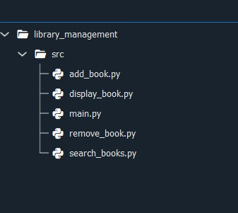
In [ ]:
library = [] def add_book(title, author, year, isbn): for book in library: if book['isbn'] == isbn:
print("Book with this ISBN already exists.") return library.append({ 'title': title,
'author': author,
'year': year,
'isbn': isbn
})
print("Book added successfully.")
def remove_book(isbn): global library for book in library: if book['isbn'] == isbn: library.remove(book) print("Book removed.") return
print("Book not found.")
def search_books(field, value):
results = [] for book in library: if str(book.get(field, '')).lower() == str(value).lower(): results.append(book) return results
def display_books(): if not library:
print("Library is empty.") return for idx, book in enumerate(library, 1): print(f"{idx}. {book['title']} by {book['author']} ({book['year']}) [ISBN: {
# Main program loop def main():
while True:
print("\nLibrary System") print("1. Add Book") print("2. Remove Book") print("3. Search Book") print("4. Display All Books")
print("5. Exit")
choice = input("Enter choice: ")
if choice == '1':
title = input("Enter title: ") author = input("Enter author: ") year = input("Enter year: ") isbn = input("Enter ISBN: ")
b
add_book(title, author, year, isbn)
elif choice == '2': isbn = input("Enter ISBN to remove: ") remove_book(isbn)
elif choice == '3':
field = input("Search by (title/author/year): ").lower() value = input("Enter search value: ") results = search_books(field, value)
if results:
for book in results:
print(f"{book['title']} by {book['author']} ({book['year']}) [ISBN:
else:
print("No matching books found.")
elif choice == '4': display_books()
elif choice == '5':
print("Exiting...") break
else: print("Invalid choice.")
if __name__ == "__main__"" main()
WEEK - 9
- Write a Python project to build a Calculator usingmodular programming
(separate module for operations).
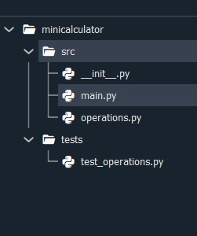
# src/calculator_app/operations.py
In [ ]:

def add(a: float, b: float) -> float:
return a + b
def subtract(a: float, b: float) -> float: return a - b
def multiply(a: float, b: float) -> float: return a * b
def divide(a: float, b: float) -> float:
if b == 0:
raise ValueError("Cannot divide by zero.")
return a /b
# src/calculator_app/main.py
import os # import pytest from operations import add, subtract, multiply, divide def calculator(): print("Welcome to Mini Calculator!\n") while True:
print("\nChoose operation:")
print("1: Add") print("2: Subtract") print("3: Multiply") print("4: Divide") print("5: Exit") choice = input("Enter choice (1/2/3/4/5): ")
if choice == "5":
print("Exiting calculator...\n") break
try:
a = float(input("Enter first number: ")) b = float(input("Enter second number: "))
except ValueError:
print("Please enter valid numbers!\n") continue
if choice == "1": print(f"Result: {add(a, b)}\n")
elif choice == "2": print(f"Result: {subtract(a, b)}\n")
elif choice == "3": print(f"Result: {multiply(a, b)}\n")
elif choice == "4":
try:
print(f"Result: {divide(a, b)}\n")
except ValueError as e:
print(f"Error: {e}\n")
else:
print("Invalid choice! Please try again.\n")
# def run_tests():
# print("Running automated tests...")
# # Absolute path to test_operations.py
# project_root = ("C:\\Users\\ramus\\calculator")
# test_file_path = ("C:\\Users\\ramus\\Downloads\\calculator\\test_operati
# # Run pytest programmatically
# result = pytest.main([test_file_path, "-q", "--tb=short"]) # if result == 0:
# print("All tests passed! ✅") # else:
# print("Some tests failed! ❌")
if __name__ == "__main__":
calculator() # run_tests()
WEEK -10
- Write a Python program that applies modularprogramming principles and defines multiple resuable functions
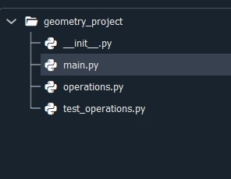
#-*- coding: utf-8 -*-
"""
Created on Mon Dec 29 15:28:42 2025
@author: ramus
In [ ]:

"""
#operations.py
#contains reusable geometry functions import math
def area_circle(radius):
return math.pi*radius*radius
def area_rectangle (length,width): return length*width
def area_triangle(base,height):
return 0.5*base*height
# -*- coding: utf-8 -*-
"""
Created on Mon Dec 29 15:28:33 2025
@author: ramus
"""
#test_operations.py
#Testing functions from operations.py from operations import area_circle,area_rectangle,area_triangle
def test_area_circle():
assert round (area_circle(1),2)==3.14 assert round (area_circle(2),2)==12.57 print("circle area tests passed")
def test_area_rectangle():
assert area_rectangle(5,4)==20 assert area_rectangle(10,3)==30 print("Rectangle area tests passed")
def test_area_triangle():
assert area_triangle(10,2)==10 assert area_triangle(6,4)==12 print("Triangle area tests passed")
def run_all_tests(): test_area_circle() test_area_rectangle() test_area_triangle()
run_all_tests()
# -*- coding: utf-8 -*-
"""
Created on Mon Dec 29 15:28:14 2025
@author: ramus
"""

#main.py
#calls functiions from operations.py to demonstrate modularity from operations import area_circle,area_rectangle,area_triangle
def main():
print("geometry utility program") print("------------------------")
#calling same function with different values print("area of circle(radius=5):",area_circle(5)) print("area of circle(radius=10):",area_circle(10))
print("area of rectangle(5*8):",area_rectangle(5,8)) print("area of rectangle(10*12):",area_rectangle(10,12))
print("area of triangle(6,4):",area_triangle(6,4)) print("area of triangle(12,10):",area_triangle(12,10)) main()

WEEK -11
- Write a Python program using modular programmingprinciples and demonstrate:
Input validation • Testing (minimum 3 test cases) • Debugging practice with comments
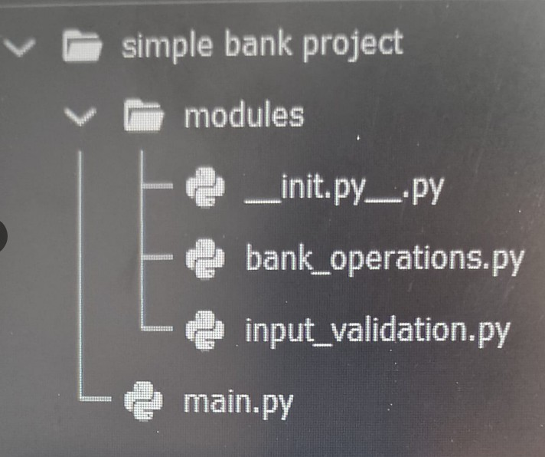
def deposit(balance, amount): balance += amount
print(f"Deposited ₹{amount}") return balance
def withdraw(balance, amount):
if amount > balance: print("Insufficient balance.") return balance balance -= amount
In [ ]:

print(f"Withdrawn ₹{amount}") return balance
def check_balance(balance): print(f"Current Balance: ₹{balance}")
def get_valid_amount(prompt):
while True:
value = input(prompt).strip()
if value == "":
print("Input cannot be empty.") continue
if not value.isdigit():
print("Please enter a valid positive number.") continue amount = int(value)
if amount <= 0:
print("Amount must be greater than zero.") continue return amount
from modules.input_validation import get_valid_amount
from modules.bank_operations import deposit, withdraw, check_balance
def main(): balance = 0
while True:
print("\n==== Simple Banking System ====")
print("1. Deposit") print("2. Withdraw") print("3. Check Balance") print("4. Exit") choice = input("Enter your choice: ").strip()
if choice == "1":
amount = get_valid_amount("Enter deposit amount: ") balance = deposit(balance, amount)
elif choice == "2":
amount = get_valid_amount("Enter withdrawal amount: ") balance = withdraw(balance, amount)
elif choice == "3":
check_balance(balance)
elif choice == "4":
print("Thank you for using Simple Bank!") break
else:
print("Invalid choice. Please select 1-4.")
if __name__== "__main__":
main()
WEEK -12
- Write a Python project for a User Registration Systemwith input validation, testing, and debugging documentation.

Algorithm
- Start program
- Display registration form (ask for username, password, email, age)
- Validate inputs:
- Username: non-empty, alphanumeric
- Password: minimum 8 chars, contains letters & numbers
- Email: must contain @ and .
- Age: must be integer ≥ 18
- If validation fails → show error message & re-prompt
- If validation passes → save user details to a file/database
- Confirm successful registration
- End program

User Registration System
def validate_username(username): if len(username) < 3: raise ValueError("Username must be at least 3 characters long") return True
def validate_email(email): if "@" not in email or "." not in email: raise ValueError("Invalid email format") return True def validate_password(password): if len(password) < 6: raise ValueError("Password must be at least 6 characters long") return True
def validate_age(age): if age < 18: raise ValueError("User must be at least 18 years old") return True
def register_user(): try: username = input("Enter username: ") validate_username(username)
email = input("Enter email: ") validate_email(email)
password = input("Enter password: ") validate_password(password)
age = int(input("Enter age: ")) validate_age(age)
print("\n✅ Registration Successful!") print("User Details:") print("Username:", username) print("Email:", email) print("Age:", age)
except ValueError as ve:
print("\n❌ Error:", ve)
except Exception as e: print("\n❌ Unexpected Error:", e)

WEEK -13
27. Write a mini-project in Python incorporating various programming concepts (loops, functions, lists, modules, validation, testing).
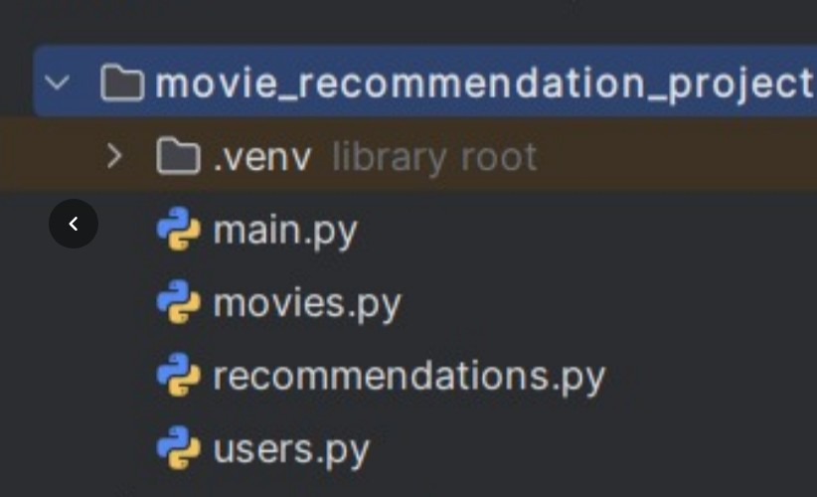
In [ ]:
# movies.py
movies = [
{"id": 1, "title": "Inception", "genre": "Sci-Fi", "rating": 8.8},
{"id": 2, "title": "Interstellar", "genre": "Sci-Fi", "rating": 8.6},
{"id": 3, "title": "The Dark Knight", "genre": "Action", "rating": 9.0},
{"id": 4, "title": "Avengers: Endgame", "genre": "Action", "rating": 8.4} {"id": 5, "title": "Forrest Gump", "genre": "Drama", "rating": 8.8},
{"id": 6, "title": "The Shawshank Redemption", "genre": "Drama", "rating"
{"id": 7, "title": "The Hangover", "genre": "Comedy", "rating": 7.7}, {"id": 8, "title": "Jumanji", "genre": "Comedy", "rating": 6.9},
]
# users.py users = {}
def register_user(username, password):
if username in users: return False
users[username] = {
"password": password,
, :

"saved_movies": []
} return True
def login_user(username, password):
if username in users and users[username]["password"] == password:
return True
return False # recommendations.py from movies import movies
def recommend_by_genre(genre):
return [movie for movie in movies if movie["genre"].lower() == genre.lower
def search_movie(title):
return [movie for movie in movies if title.lower() in movie["title"].lower
# main.py
from users import register_user, login_user, users from recommendations import recommend_by_genre, search_movie current_user = None
def show_menu():
print("\n--- Movie Recommendation System ---")
print("1. Register") print("2. Login") print("3. Search Movie")
print("4. Get Recommendations by Genre") print("5. Save Movie to Watch Later")
print("6. View Saved Movies") print("7. Exit")
while True:
show_menu()
choice = input("Enter your choice: ")
if choice == "1":
username = input("Enter username: ") password = input("Enter password: ") if register_user(username, password):
print("Registration successful!")
else:
print("User already exists.")
elif choice == "2":
username = input("Enter username: ") password = input("Enter password: ") if login_user(username, password):
current_user = username

print("Login successful!")
else:
print("Invalid credentials.")
elif choice == "3":
title = input("Enter movie title to search: ") results = search_movie(title) if results:
for movie in results:
print(movie)
else:
print("No movie found.")
elif choice == "4":
genre = input("Enter genre (Action/Drama/Comedy/Sci-Fi): ") recommendations = recommend_by_genre(genre) if recommendations:
for movie in recommendations:
print(movie)
else:
print("No recommendations found.")
elif choice == "5":
if not current_user:
print("Please login first.") continue
movie_title = input("Enter movie title to save: ") results = search_movie(movie_title) if results:
users[current_user]["saved_movies"].append(results[0])
print("Movie saved to Watch Later list.")
else:
print("Movie not found.")
elif choice == "6":
if not current_user:
print("Please login first.") continue
saved = users[current_user]["saved_movies"] if saved:
print("\nYour Watch Later List:") for movie in saved:
print(movie)
else:
print("No movies saved yet.")
elif choice == "7":
print("Exiting system. Thank you!") break
else:
print("Invalid choice. Try again.")

